1. C program to calculate sum of elements in an array?

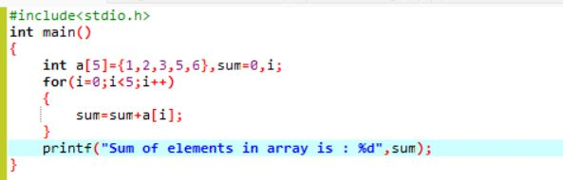



1. C program to merge two array ?

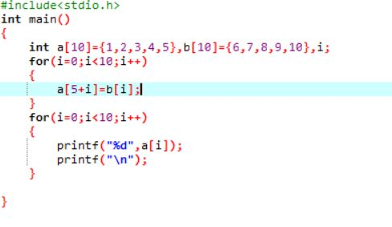

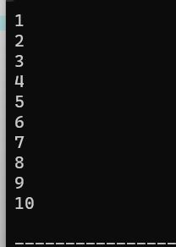

1. Write a c program to perform insert in deletion in middle in an array?

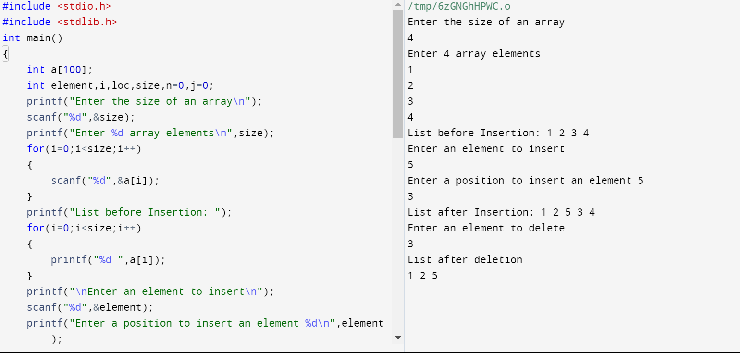

1. Write a c program to reverse a string?

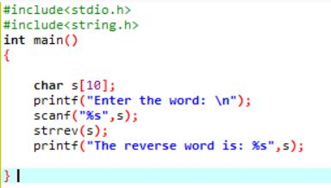

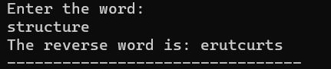

1. Write a c program to check given string is palindrome or not?

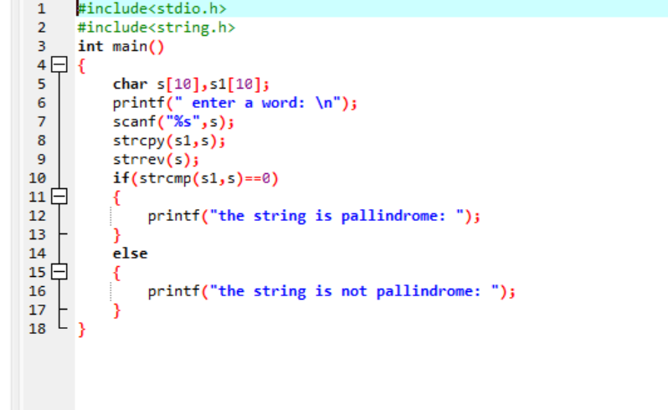

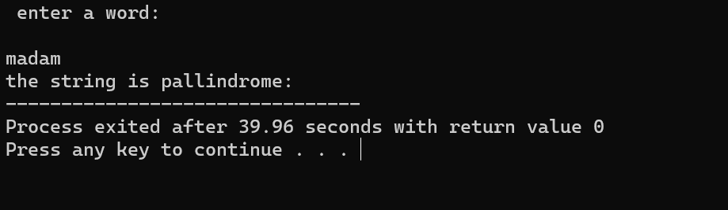

1. Write a c program to search a particular character in string?

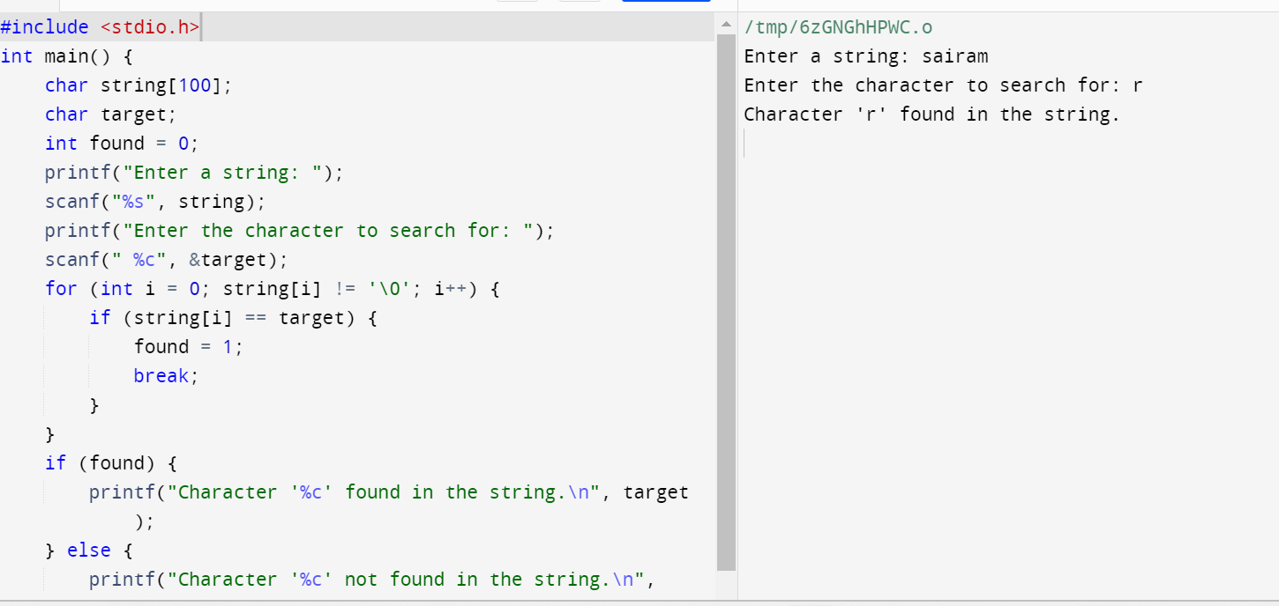

1. Write a c program to count number of times a,e,i,o,u present in given string?

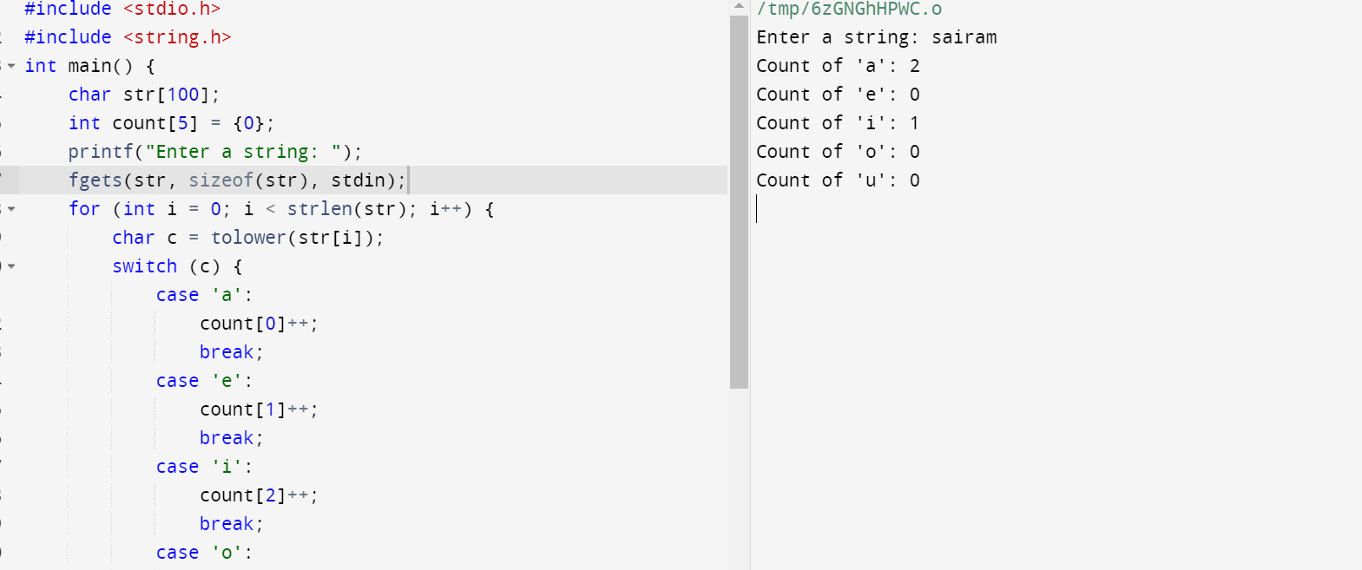

1. Write a c program to perform matrix multiplication?

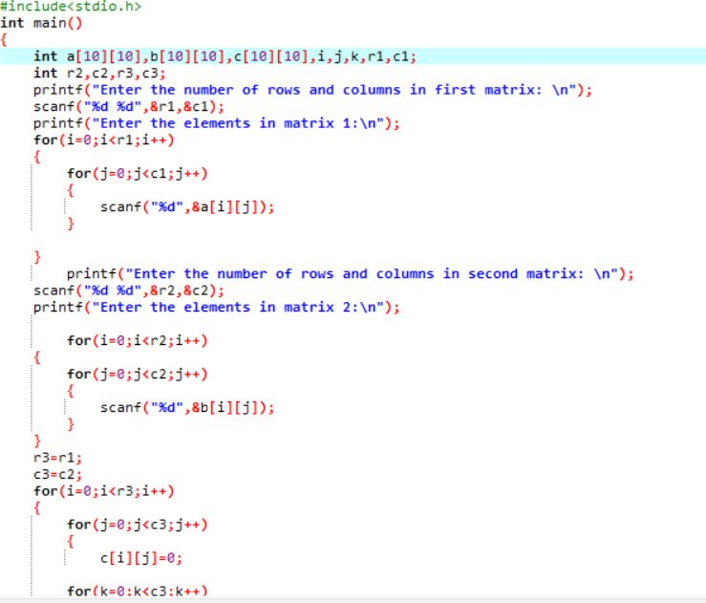

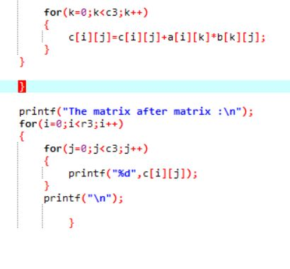

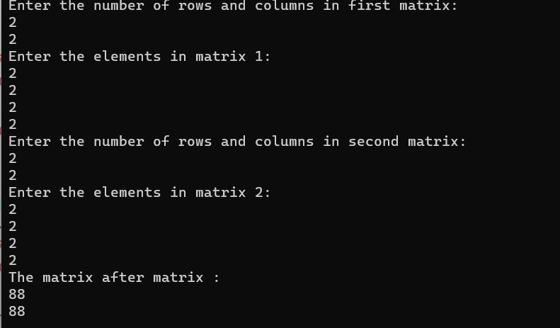

1. Write a c program to perform string mancluations?

